

**NETAJI SUBHAS INSTITUTE OF TECHNOLOGY 2017**

Teacher Classroom

**A Python based WEB DEVELOPMENT PROJECT**

For

**WINTER TRAINING**

Submitted to

**DEPARTMENT OF COMPUTER ENGINEERING**

For the award of the degree of

**BACHELOR OF TECHNOLOGY**

**IN**

**COMPUTER ENGINEERING**



NETAJI SUBHAS INSTITUTE OF TECHNOLOGY

DEPARTMENT OF COMPUTER ENGINEERING

May 2018

**Certificate**

This is to certify that this project report entitled Sebonaché by Sarthak Srivastava (350/CO/15), submitted in partial fulfillment of the requirements for the degree of Bachelor of Engineering in Computer Engineering under Netaji Subhas Institute of Technology, during the academic year 2018, is a bonafide record of work carried out under my guidance and supervision.

**Table of Contents**

TOPIC- Page No.

1. Project Problem statement 4

2. Approach 5-6

3. Tech Stack 7-8

4. Code and Explanation 9-11

5. Screenshots 12-19

6. Future Advancements 20

7. References 21

**1. Project Problem Statement**

The project aims at building a web application for maintaining college student teacher records and files. The web application mainly has teacher-student portal where each student can get their specific teacher college information like their, timetable, their profile, assignments to be submitted etc. The web application has following features:

1. Teachers section where a teacher can login and perform the following operations:

* Update their profile.
* Update timetable.
* Upload assignments for a particular class of students.
* Receive assignment submissions and queries.

2. Students section where each student can see the particular teacher’s profile and timetable. They can check if there is an assignment due or not and can submit assignments as well as post queries related to anything to the teacher on the web portal. This in turn notifies the teacher about the query and the teacher can contact student about it and clarify his doubts.

3. There is an additional feature of classroom discussion where in a teacher creates specific discussion forum for each class and students and teacher can interact there.

The site has the functionality where:

a. Students can ask questions.

b. Put up and view important links.

Anyone can answer the questions in between the class.

**2. Approach**

**Django Framework**

Django is a widely used Python web application framework with a "batteries-included" philosophy. The principle behind batteries-included is that the common functionality for building web applications should come with the framework instead of as separate libraries. For example, authentication, URL routing, a template engine, an object-relational mapper (ORM), and database schema migrations are all included with the Django framework.

Advantages of Django

* Fast: This has been designed in a way to help the developers make an application as fast as possible. From idea, production to release, Django helps in making it both cost effective and efficient. Thus it becomes an ideal solution for developers having a primary focus on deadlines.
* Fully Loaded:It works in a way that includes dozens of extras to help with user authentication, site maps, content administration, RSS feeds and much more such things. These aspects help in carrying out the web development process completely.
* Secure: When you are doing it in Django, it is ensured that developers don’t commit any mistakes related to security. Some of the common mistakes include SQL injection, cross-site request forgery, click jacking and cross-site scripting. To manage effectively usernames and passwords, the user authentication system is the key.
* Scalable:To meet the heaviest traffic demand, the benefits of Django framework can be seen. Therefore, the busiest sites use this medium to quickly meet the traffic demands.

**MVC Model Django**

When talking about applications that provide UI (web or desktop), we usually talk about MVC architecture. And as the name suggests, MVC pattern is based on three components: Model, View, and Controller.

* The model (M) is a model or representation of our data. It’s not the actual data, but an interface to the data. The model allows us to pull data from our database without knowing the intricacies of the underlying database. The model usually also provides an abstractionlayer with our database, so that we can use the same model with multiple databases.
* The view(V) is what we see. It’s the presentation layer for our model. On our computer, the view is what we see in the browser for a Web app, or the UI for a desktop app. The view also provides an interface to collect user input.
* The controller(C) controls the flow of information between the model and the view. It uses programmed logic to decide what information is pulled from the database via the model and what information is passed to the view. It also gets information from the user via the view and implements business logic: either by changing the view, or modifying data through the model, or both.

**3.Tech Stack**

a. Python: Python is an interpreted high-level programming language for general-purpose programming. Mainly used in Django framework in the project.

b. Django: Django is a high-level Python Web framework that encourages rapid development and clean, pragmatic design.

c. Sqlite3: SQLite is a relational database management system contained in a C programming library. In contrast to many other database management systems, SQLite is not a client–server database engine. Rather, it is embedded into the end program.

d. HTML/CSS

The webpages were built through HTML and styled with help of CSS. Javascript was included in the HTML file using the EJS files.

e. Javascript

Various javascript features were used while designing the application in order to improve the functionality. The different javascript files used and experimented were:

Howler JS, AngularJS, Paper JS, EJS.

f. Node.js

Node was used to provide the basic framework for the classroom website. It helps in providing dynamic features on the server side. The various node modules used are as follows:

body-parser, cookie-parser, ejs, express, express-session, jade, method-override, mongoose, morgan, passport, passport-local-mongoose,serve-favicon.

g. Mongo DB: MongoDB has been used to manage the database with three different models, which are referencing each other.

h. Herkou

The app was deployed on the heroku provided url so as to get a SSL certifacte for the efficient running of the site.

i. mLab: mLab were used to maintain the databases online for the web application to access data, rather than from a local database.

**4. Code and Explanation**

1.model.py : Following code shows the python file model.py which is used to define all the models (tables) to be used in the database.

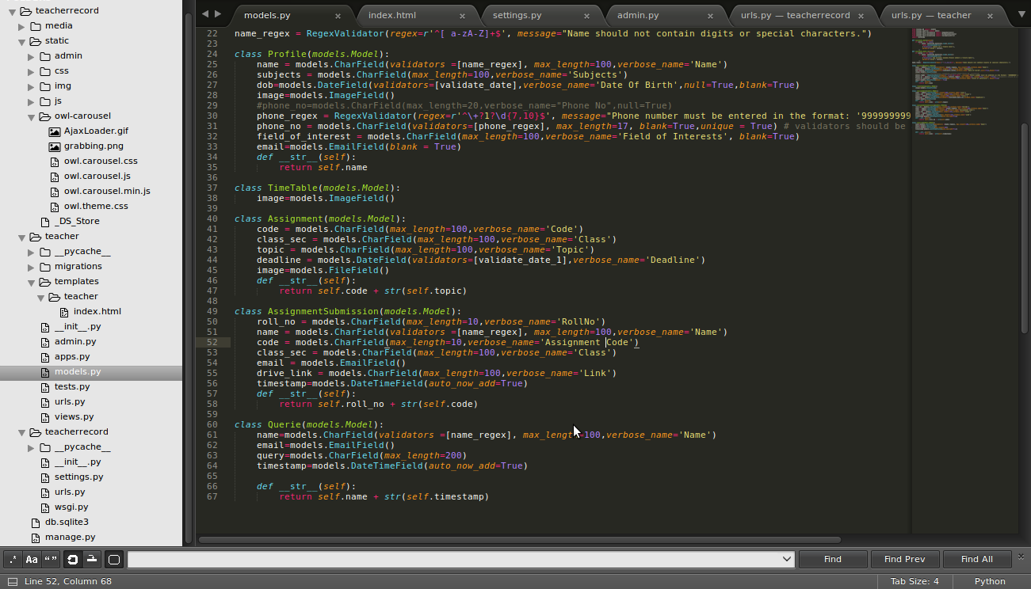

2) settings.py : Following code shows the python file settings.py which is used to define all the basic settings of the project like database and the timezone to be used.

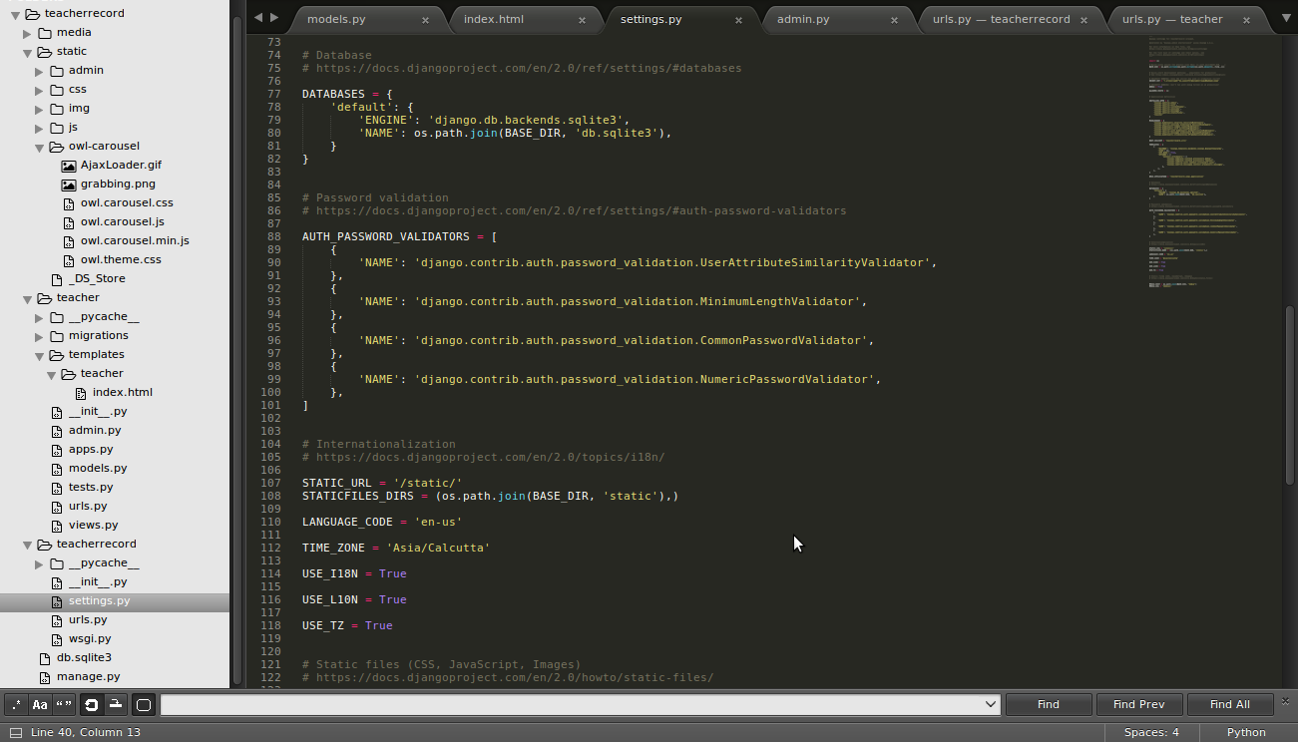

3) index.html : Contains all the Html code of the front end.

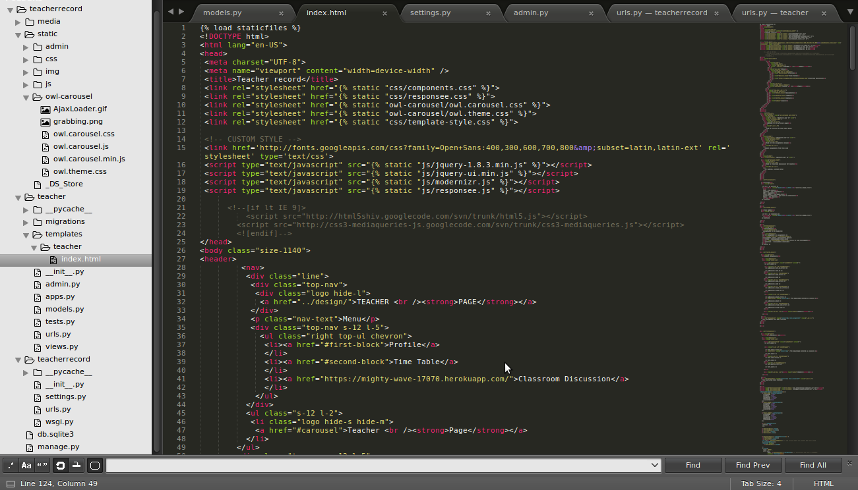

4) urls.py : It is used to define all the urls of the project.

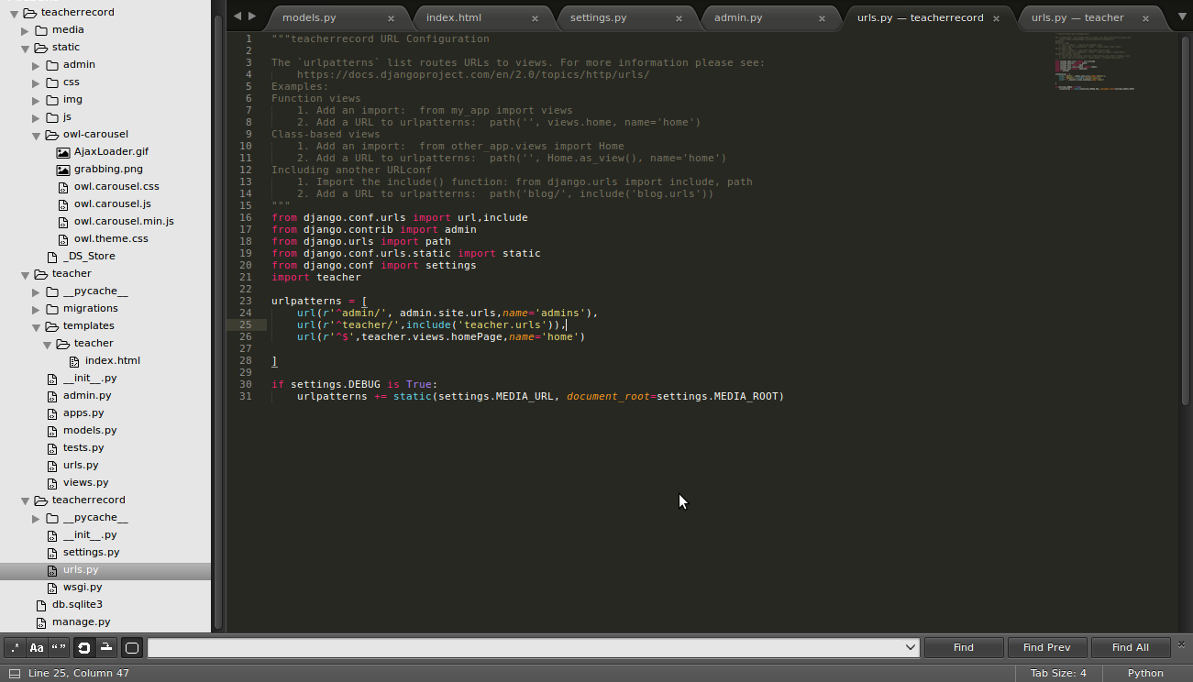

5) views.py: Forms a link between models and the front end code. It is used to define variables to be used at the front end and to push data into models.

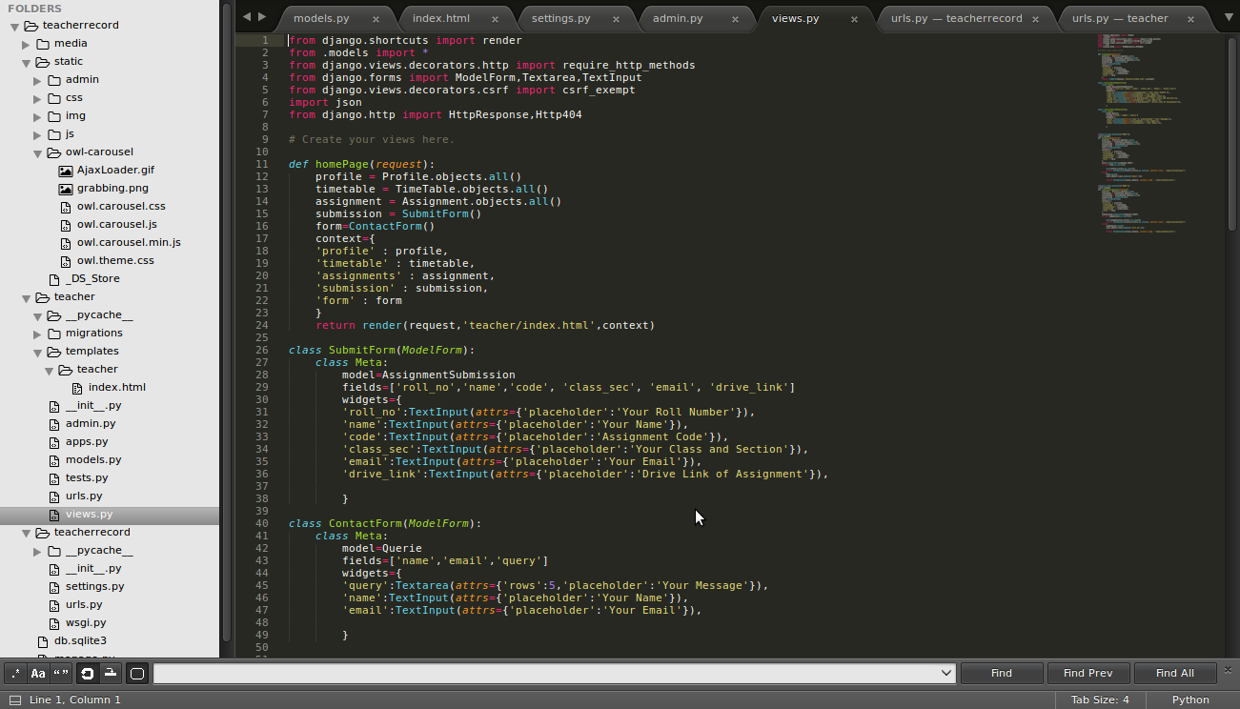

6) admin.py : To make the administrator views of the models.

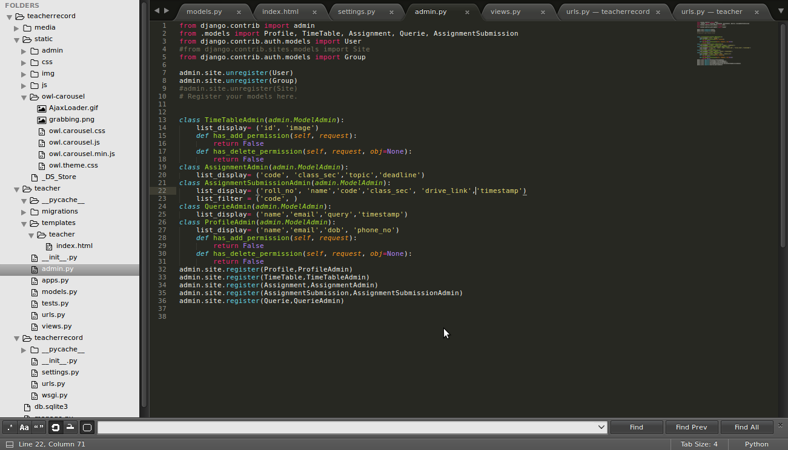

**5. Screenshots**

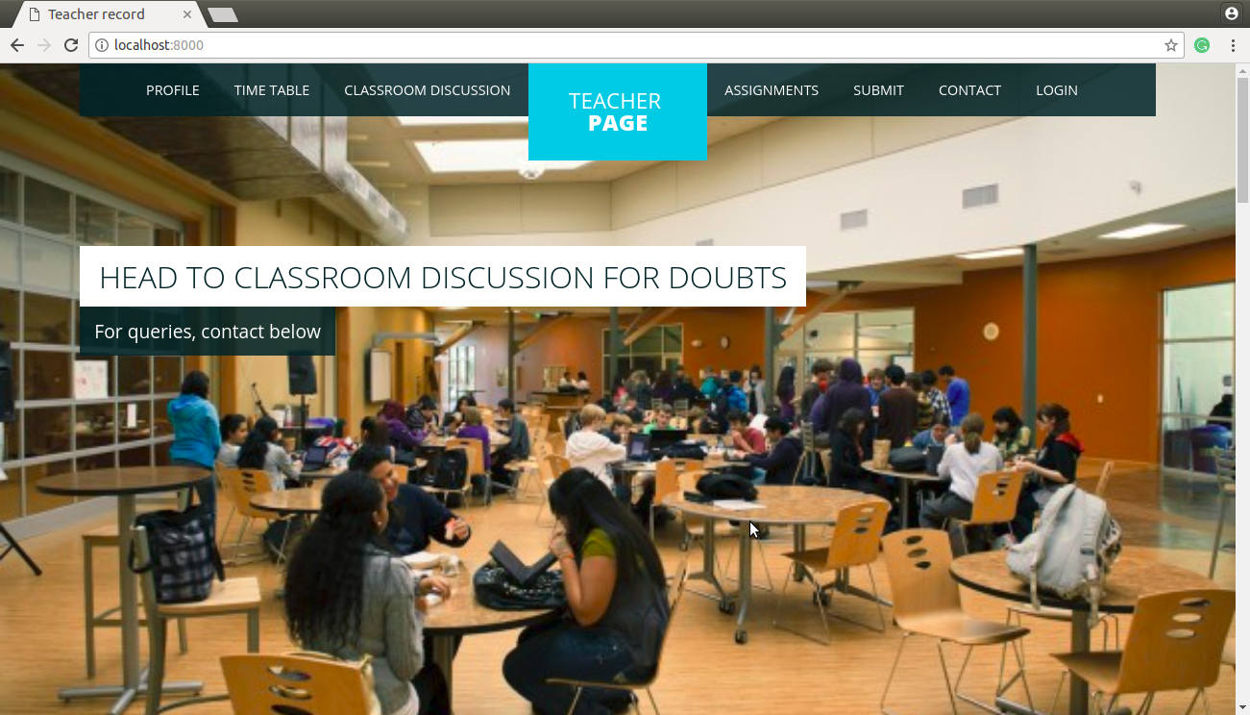

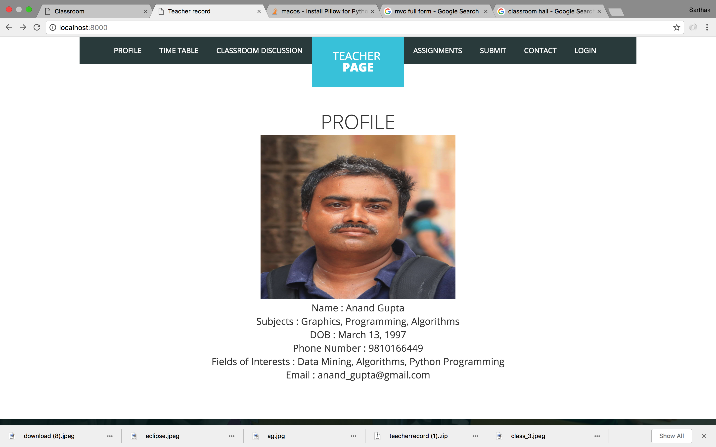

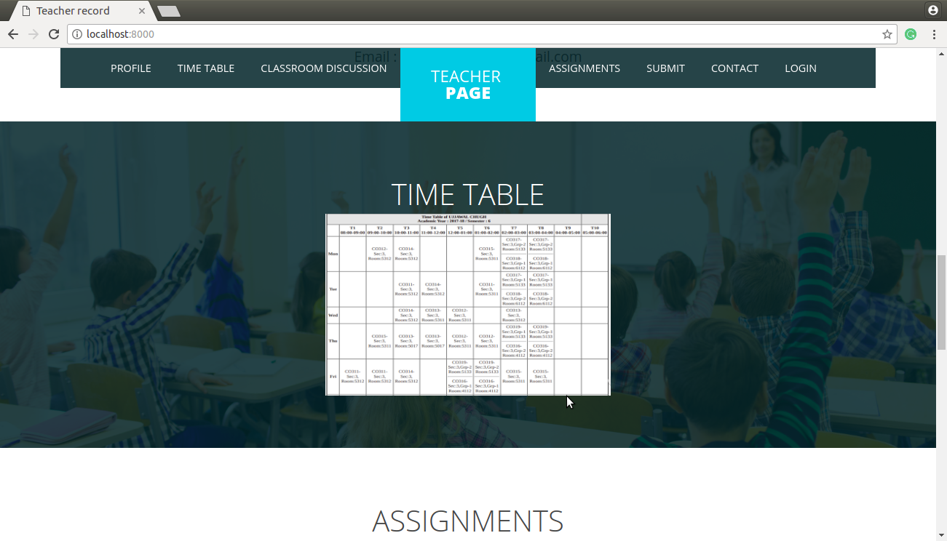

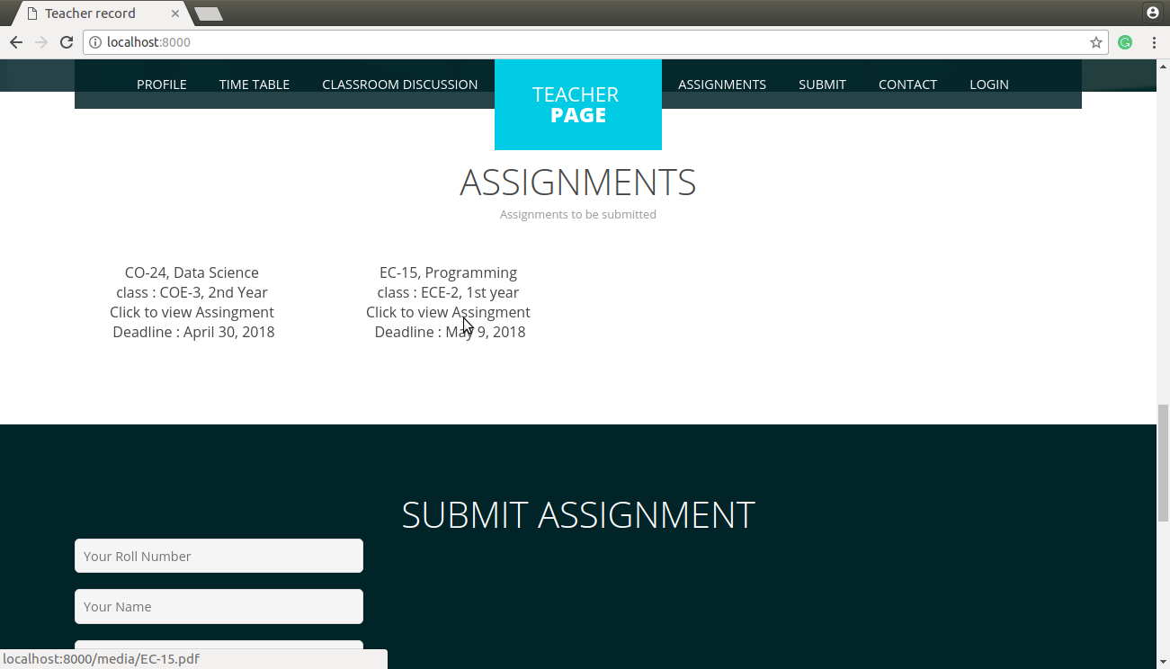

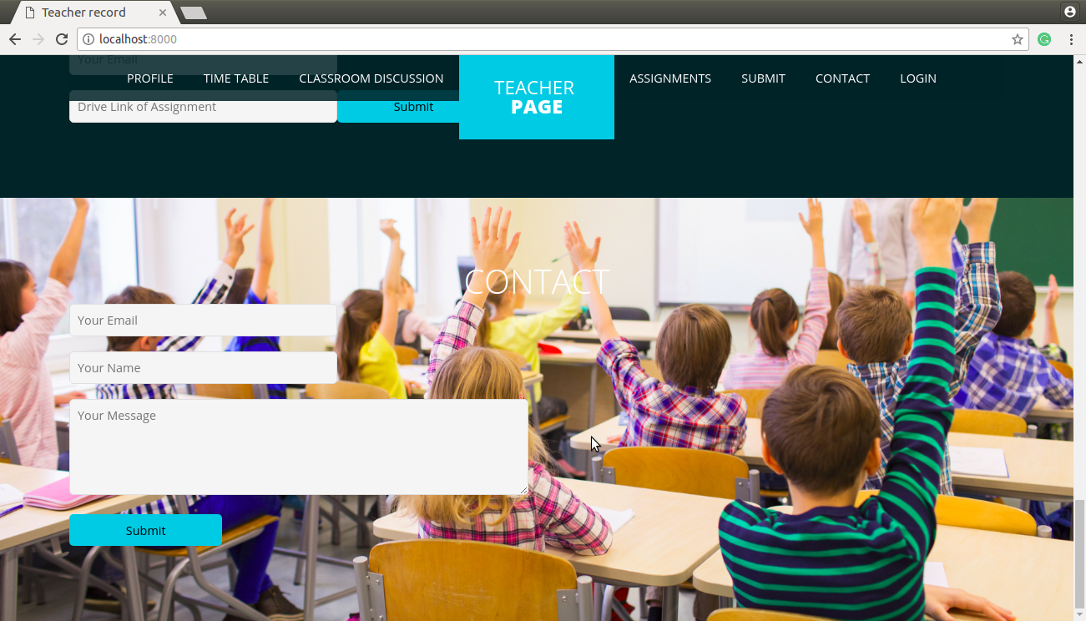

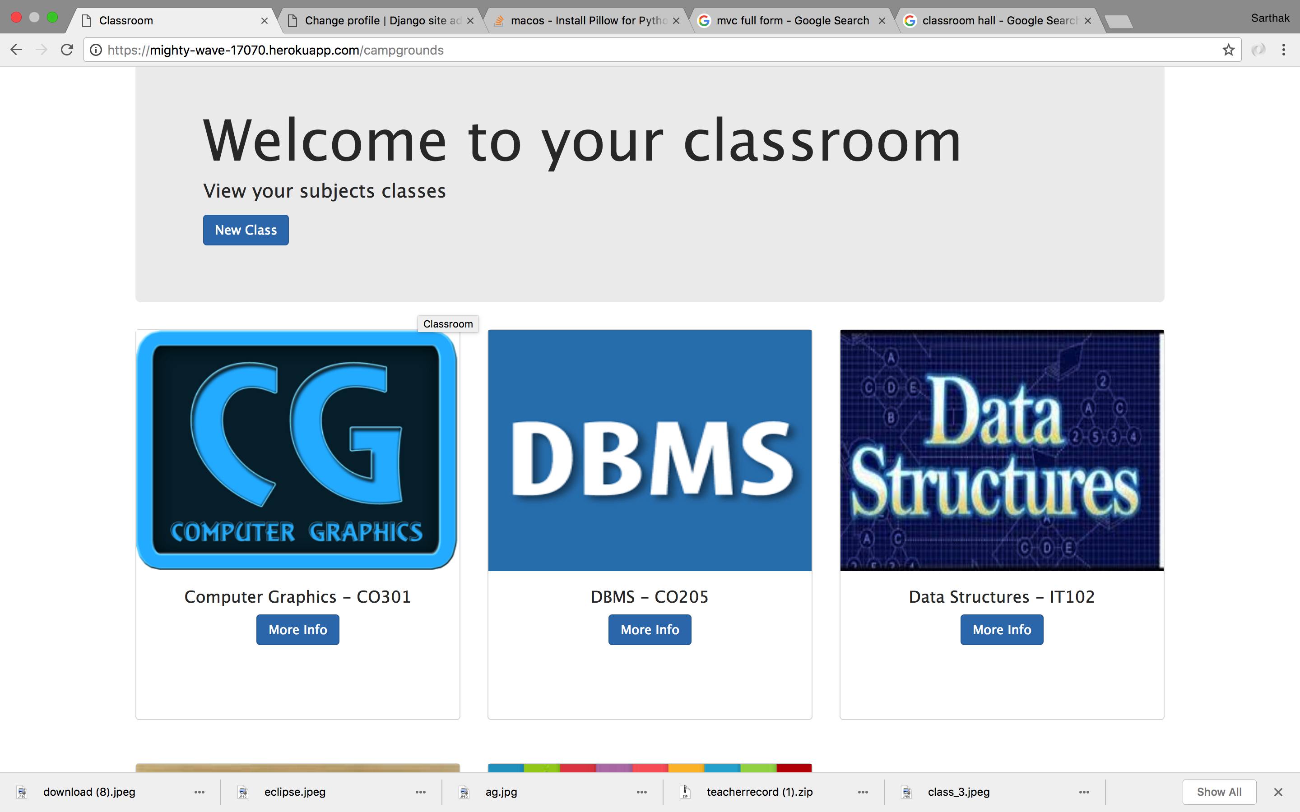

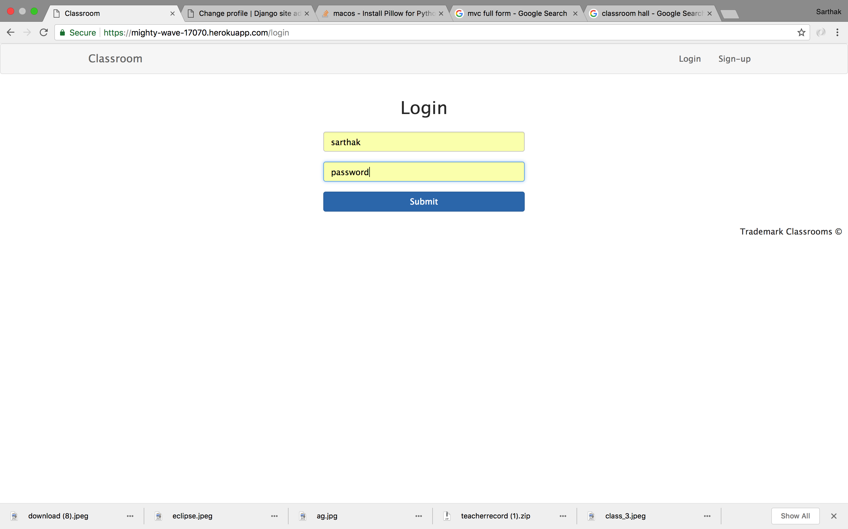

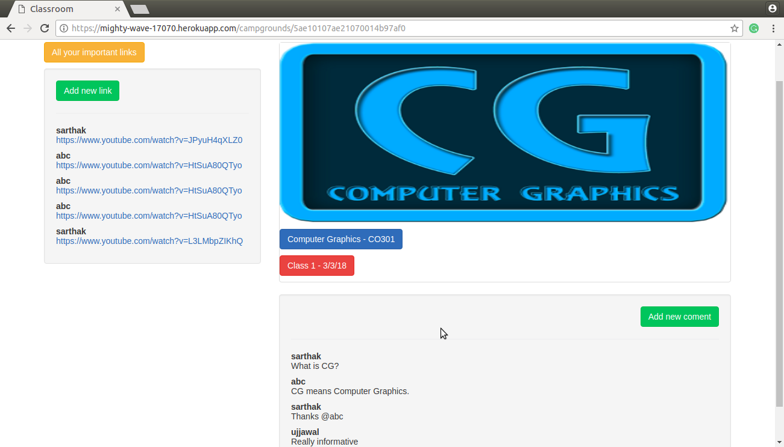

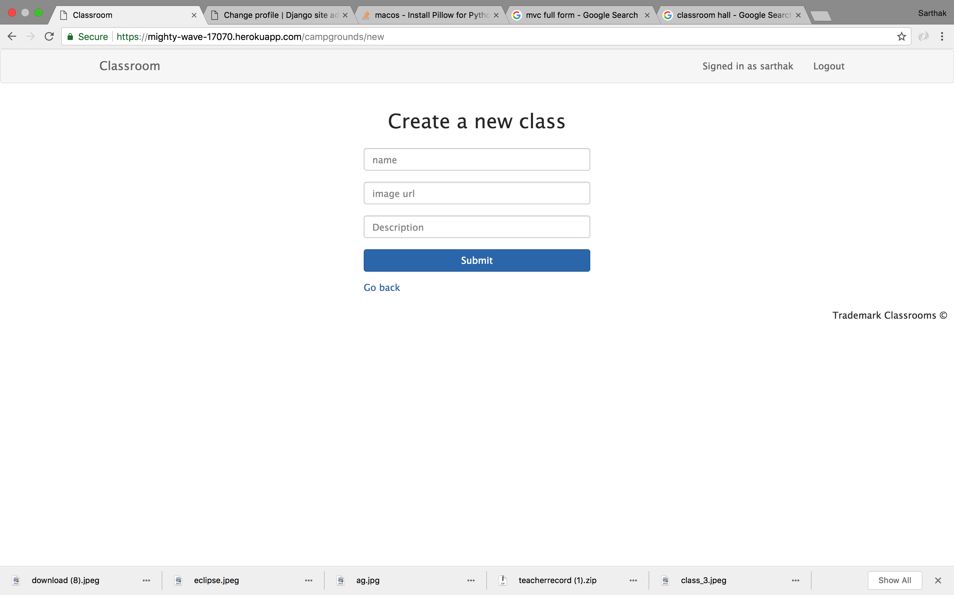

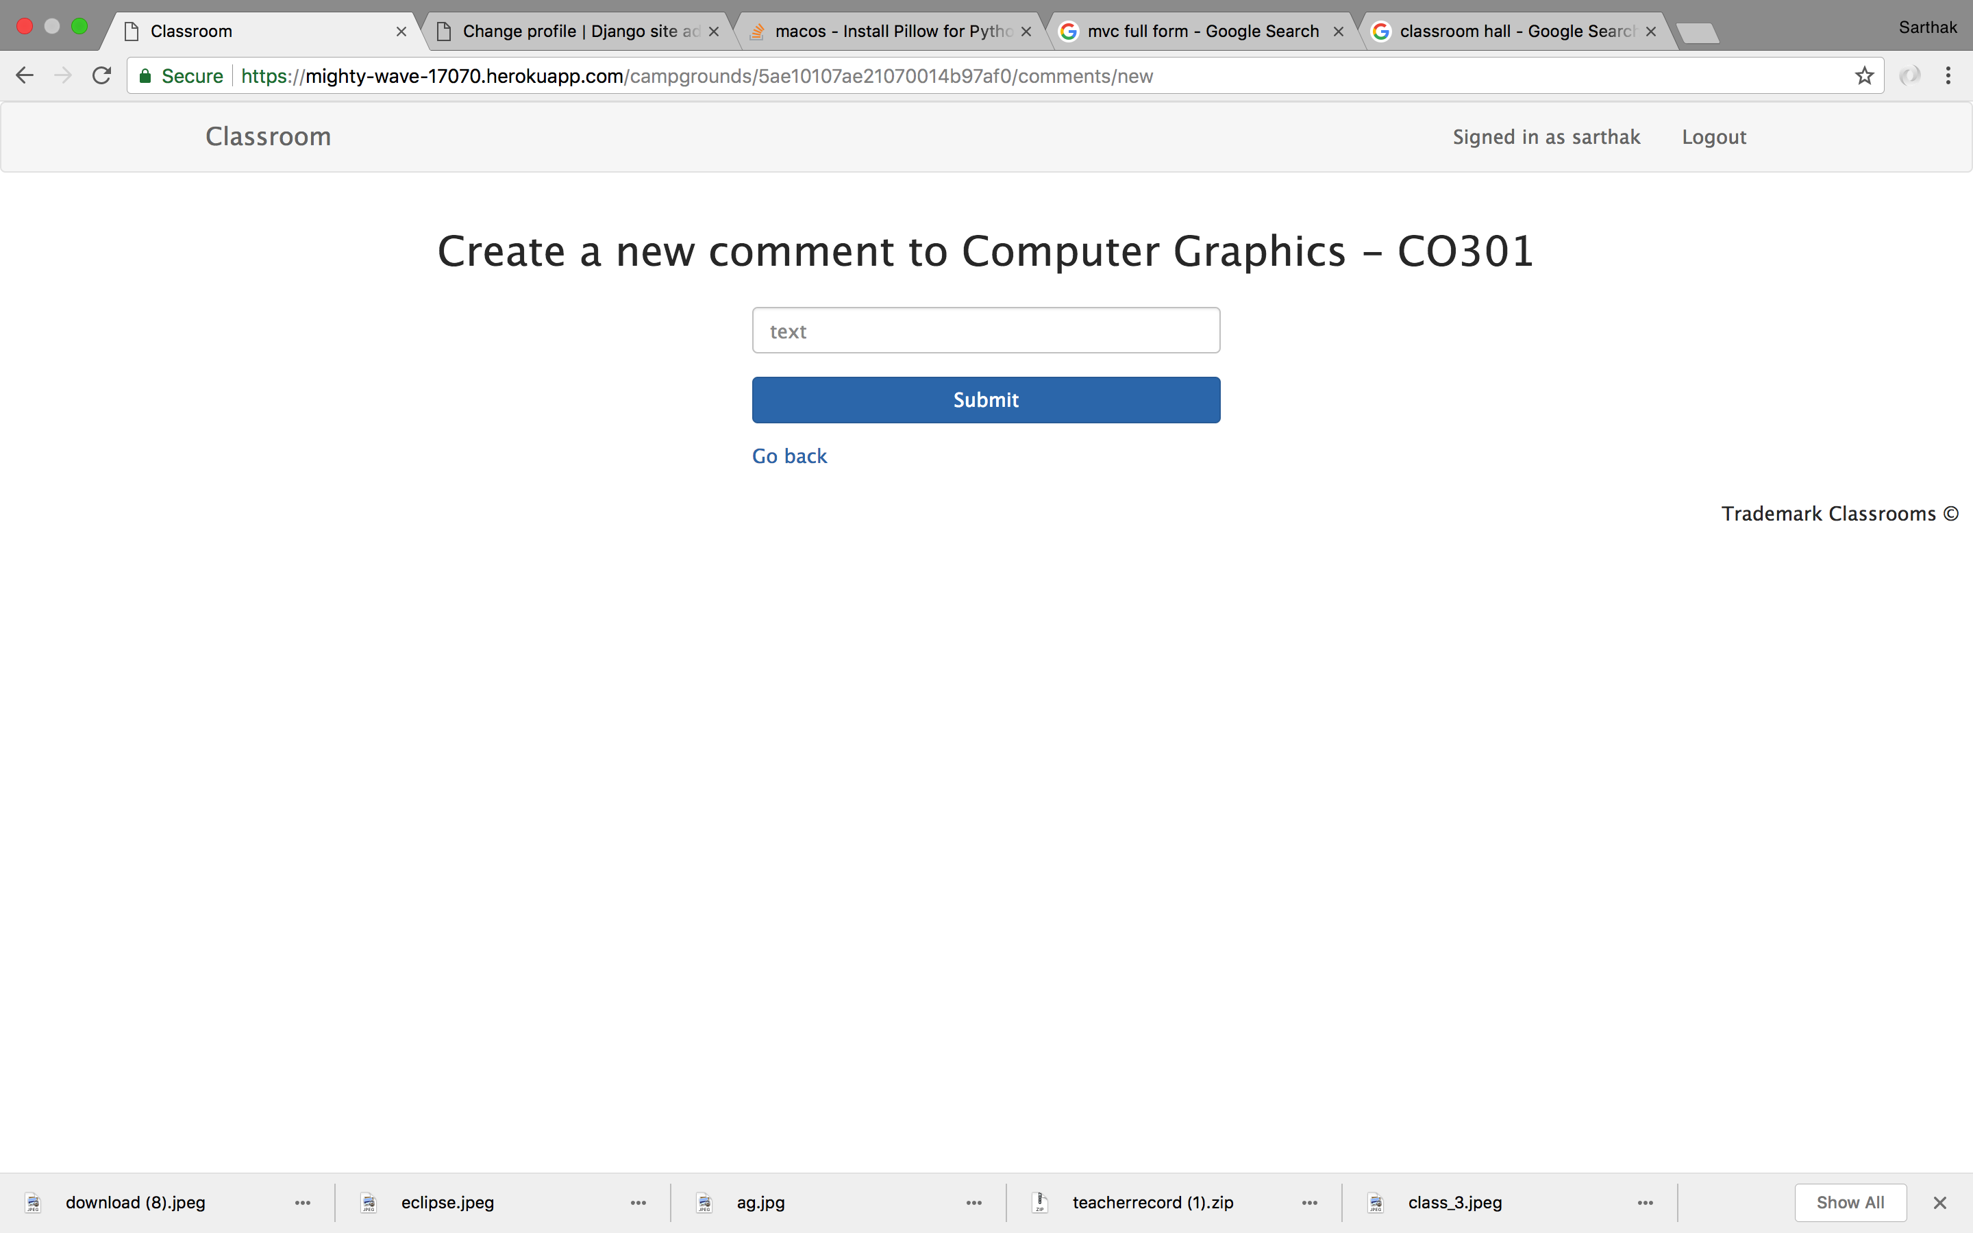

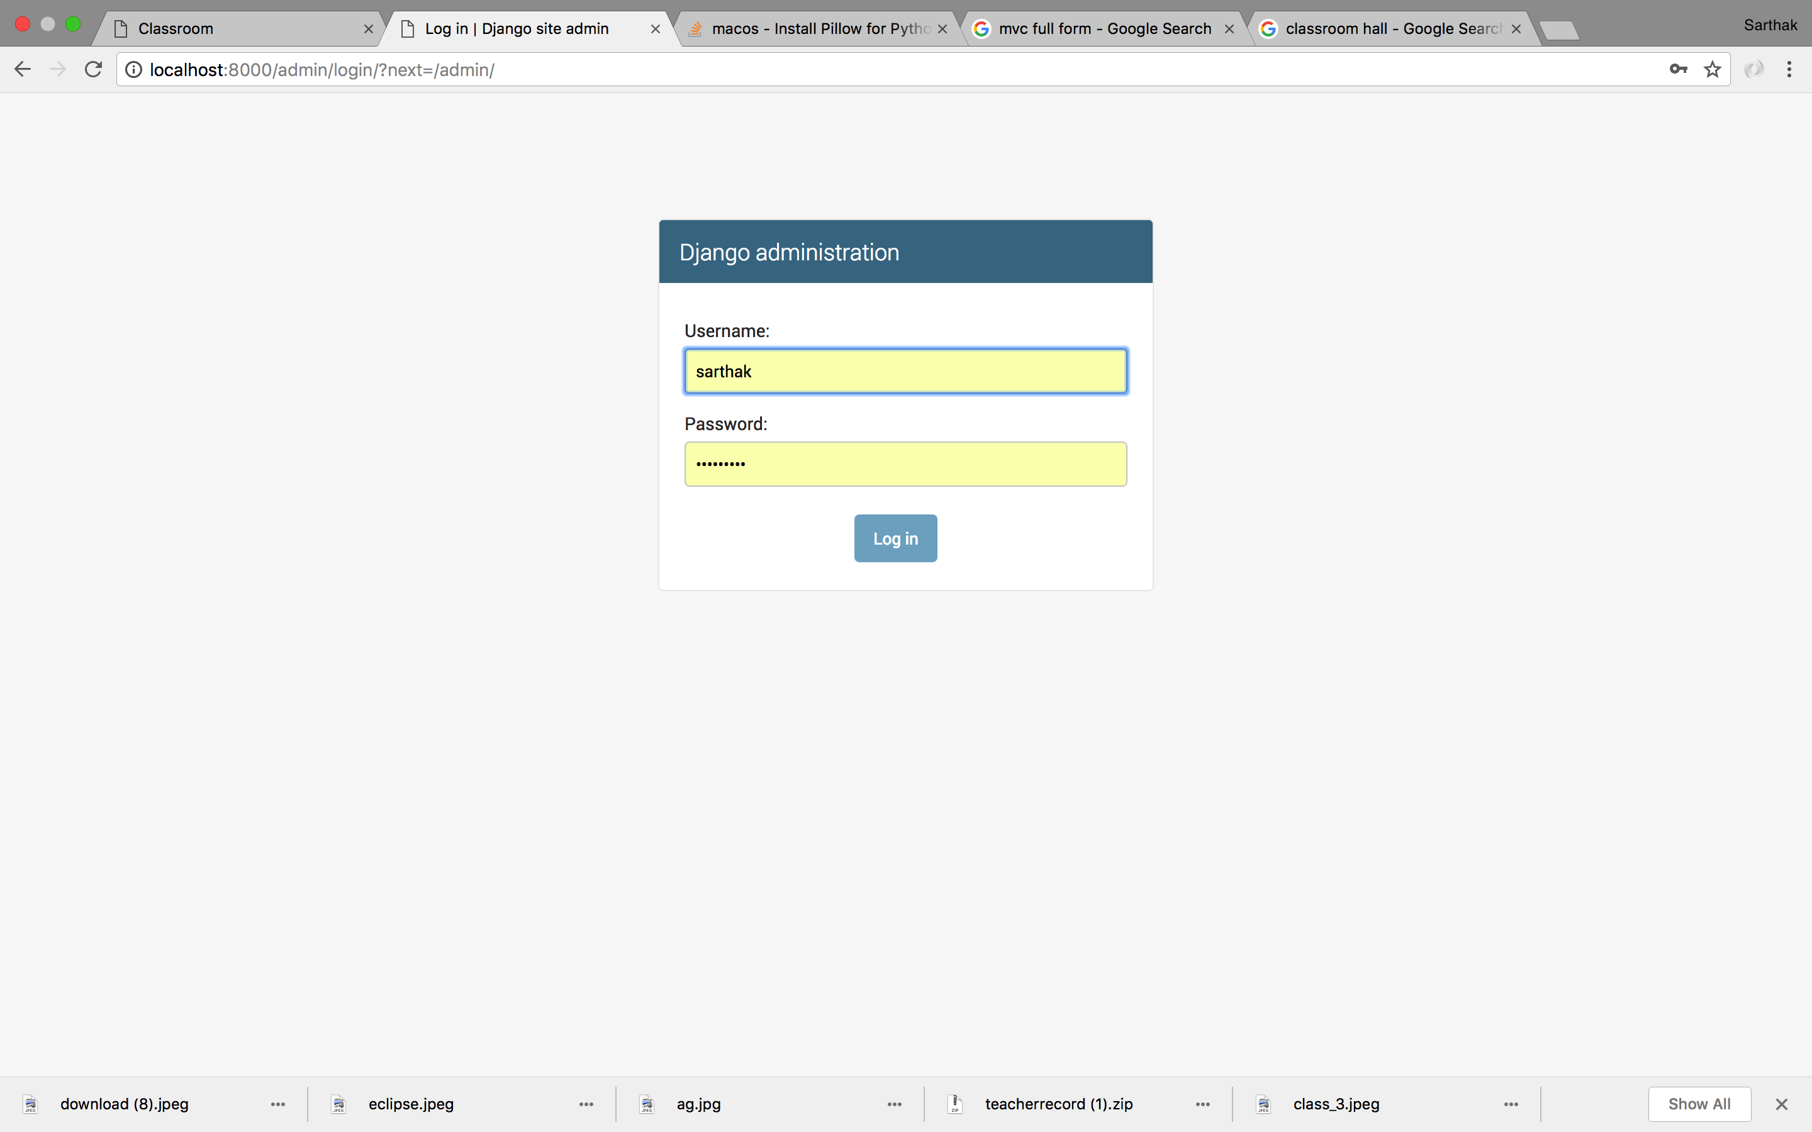

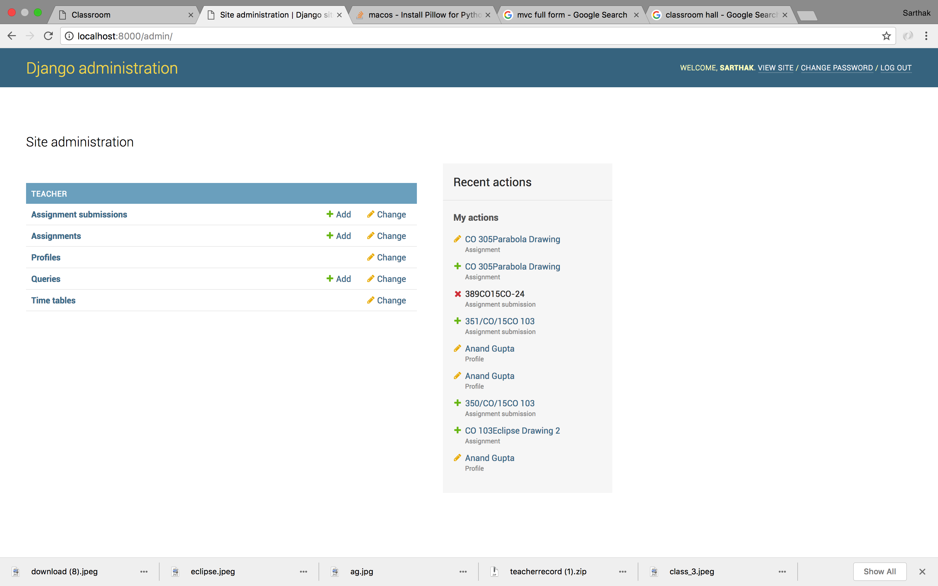

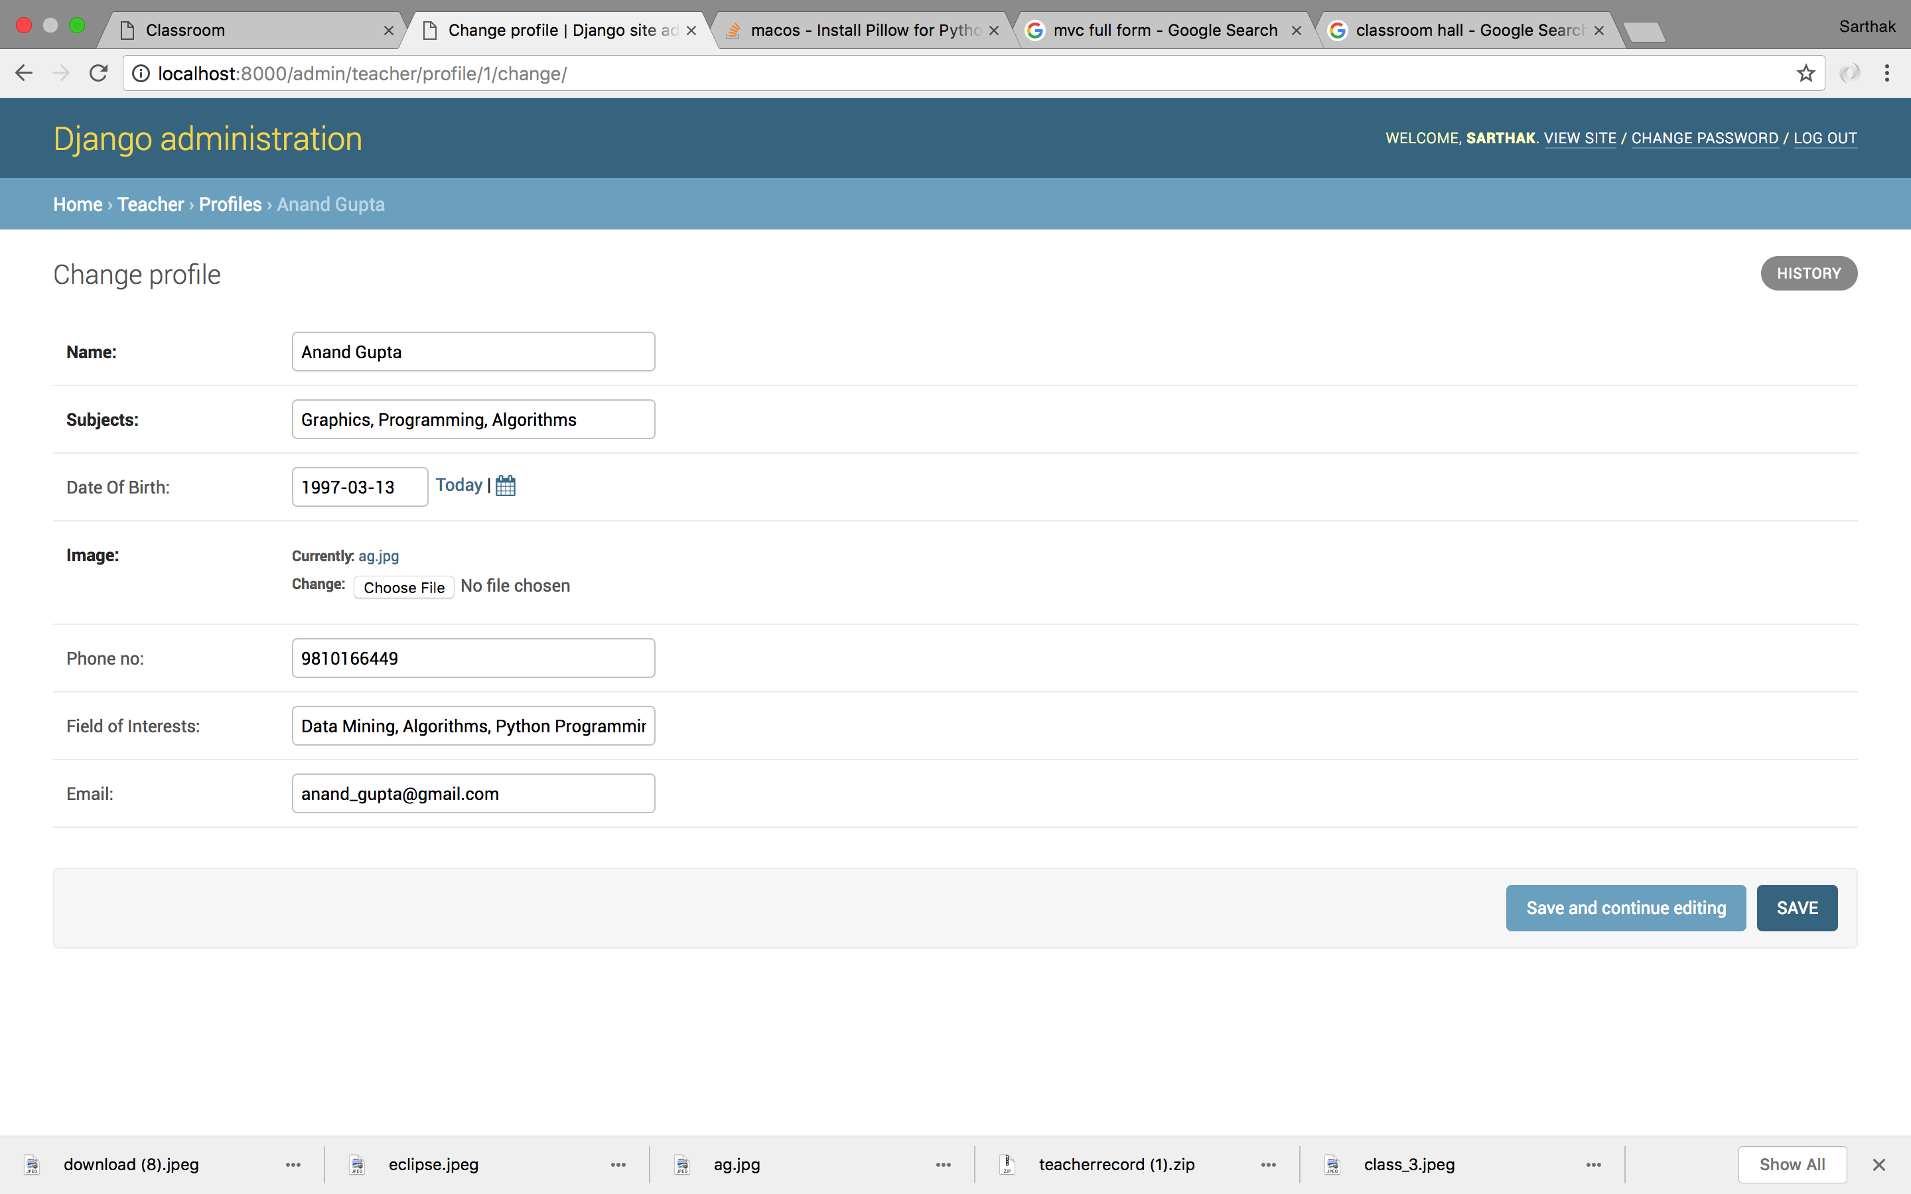

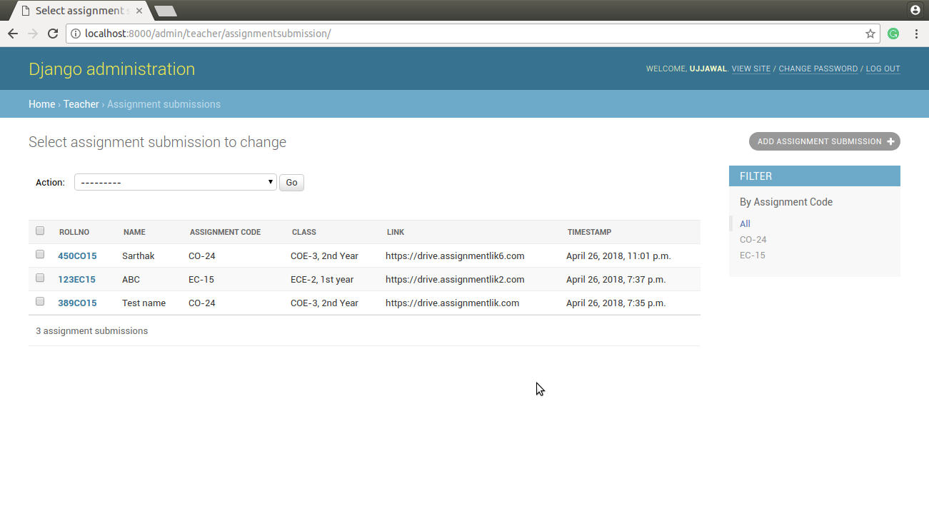

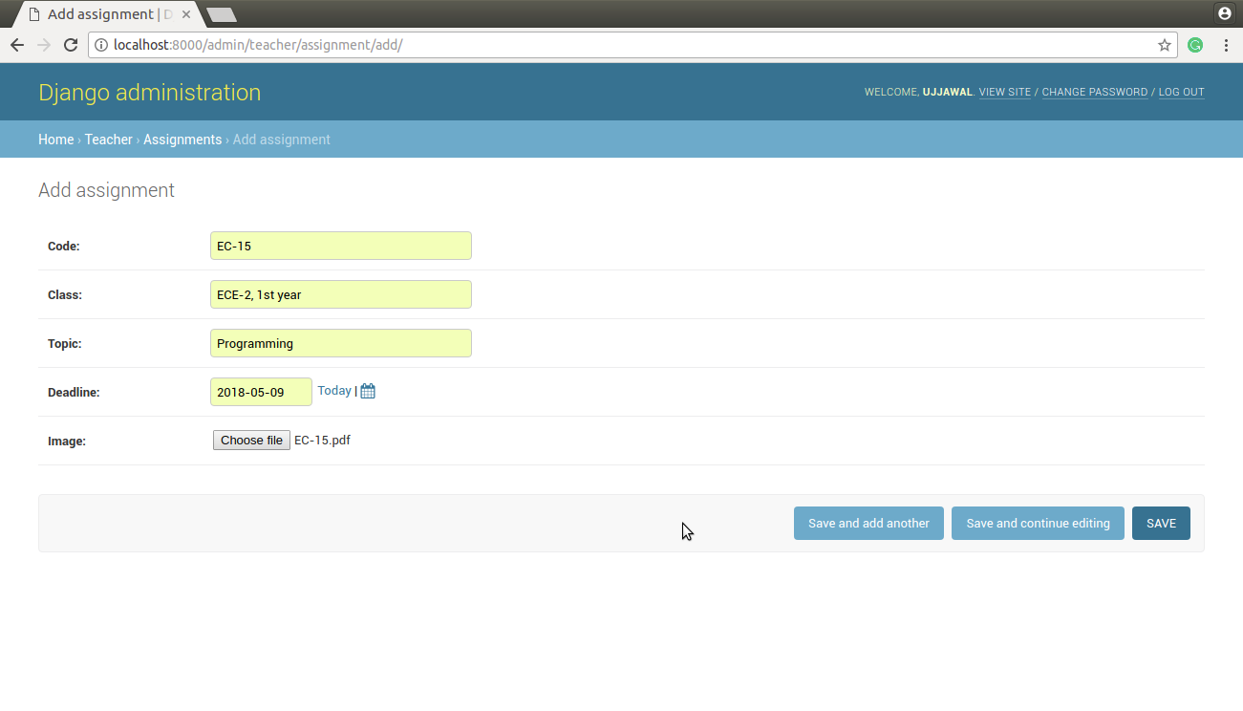

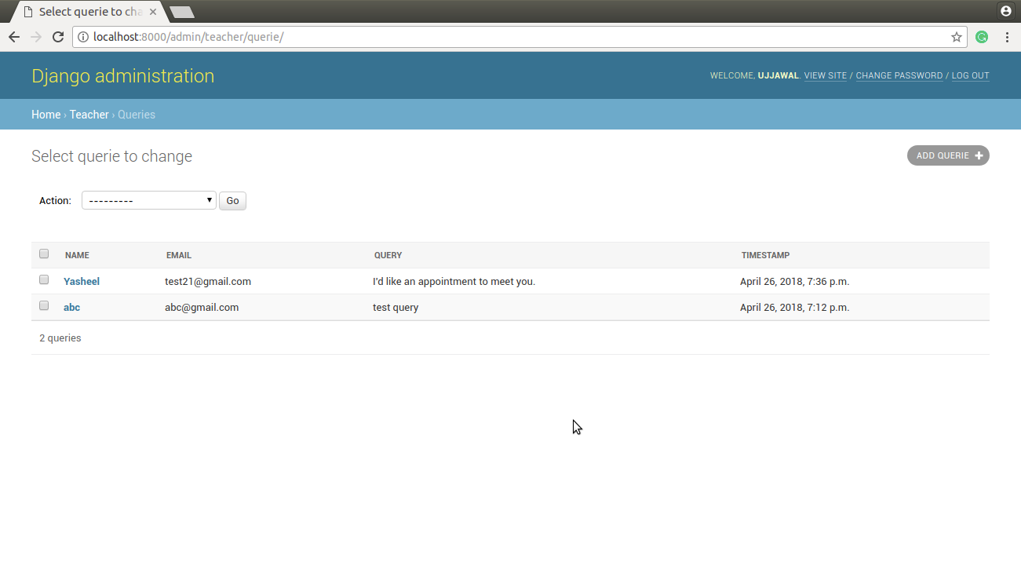

**6. Future Advancements**

* The site can be further expanded for all the teachers in the university.
* The students can submit all their assignment work and projects on the portal.
* The whole college record system can be digitized in this manner and use of paper can be avoided.
* The classroom interface can be further improvised by showing a live feed of the classroom to the students at a later point of time.
* All the doubts of students and important notes can be found in the comments section at any later point of time.
* All the important links provided by the teacher can be seen on the right side of the window and can further be improved to monitor all the assignments related to that class as well.

The functionality and scalability of the site further enables us to implement it for a university and also enhance the student experience by creating their profile.

**7. References**

* <https://www.youtube.com/playlist?list=PL6gx4Cwl9DGAcbMi1sH6oAMk4JHw91mC_>
* <https://www.fullstackpython.com/django.html>
* <https://getbootstrap.com/>
* <https://www.codeschool.com/courses/try-django>
* <https://www.youtube.com/watch?v=Ky59C5geOtg>
* a.<https://www2.stat.duke.edu/courses/Fall10/sta205/lec/topics/rn.pdf>
* <https://en.wikipedia.org/wiki/Facebook_Platform>
* <https://nodejs.org/api/documentation.html>